Frontend Development with React.js

**Project Documentation**

# Introduction

Project Title: Store Manager – Inventory Tracking System

Team ID: (NM2025TMID39060)

Team Leader: Sandhiya A

(Mail ID: [24bsccs29@cttewc.edu.in)](mailto:24bsccs29@cttewc.edu.in)

Team Members:

Karthiga S

(Mail ID: [24bsccs40@cttewc.edu.in)](mailto:24bsccs40@cttewc.edu.in)

Zainab Fathima A

(Mail ID:[24bsccs26@cttewc.edu.in)](mailto:24bsccs26@cttewc.edu.in)

Sumithra G

(Mail ID: [24bsccs55@cttewc.edu.in)](mailto:24bsccs55@cttewc.edu.in)

# Project Overview

Purpose:The Store Manager project is designed to simplify inventory tracking and management for stores. It ensures healthy stock levels, facilitates sales, and maintains accurate records.

Features:

* + Inventory Management: Maintain healthy stock levels in a store.
  + Stock Updates: Automatically update stock after sales or restocks.
  + Cart: Add products with quantities for checkout.
  + Checkout at Cart: Updates inventory, clears cart, and stores sale record.
  + Adding New Products: Add products with name, image URL, price, stock, and tags.
  + Alert View for Depleting Stock: Highlight low stock items in red.
  + Search Functionality: Search products within inventory and catalog.
  + Sale Records: Maintain sale history with value, products, and datetime.

# Architecture

Component Structure:- Inventory Component- Cart Component- Checkout Component- Add Product Component- Alert Component- Search Component- Sale Records Component

State Management:Context API or Redux can be used for managing global state such as cart, inventory, and sales. Routing:React Router can be used to navigate between pages such as Inventory, Cart, and Sales Records.

# Setup Instructions

Prerequisites: Node.js, npm or yarn. Installation:

* + Clone the repository.
  + Navigate to the project folder.
  + Run `npm install` to install dependencies.
  + Run `npm start` to launch the app.

# Folder Structure

Client: Contains React application (components, pages, assets). Utilities: Contains helper functions, hooks, and constants.

# Running the Application

Command:npm start

# Component Documentation

Key Components: Inventory List, Cart, Checkout, Add Product, Alerts, Search, Sale Records. Reusable Components: Button, Input, Modal, Card.

# State Management

Global State: Inventory, Cart, Sale Records.

Local State: UI interactions such as modals, form inputs.

# User Interface

Pages:- Inventory Page (list of products + add product option).- Cart Page (added products + checkout).- Sales Records Page (all past transactions).- Alert View (depleting stock highlighted).

(Screenshots can be added later when UI is ready.)

# Styling

CSS Frameworks/Libraries: Tailwind CSS / Bootstrap (or plain CSS). Theming: Optional light/dark mode.

# Testing

Testing Strategy:Unit testing (components), integration testing (cart & checkout), end-to-end testing (inventory updates).

Code Coverage:Jest + React Testing Library.

# Screenshots or Demo

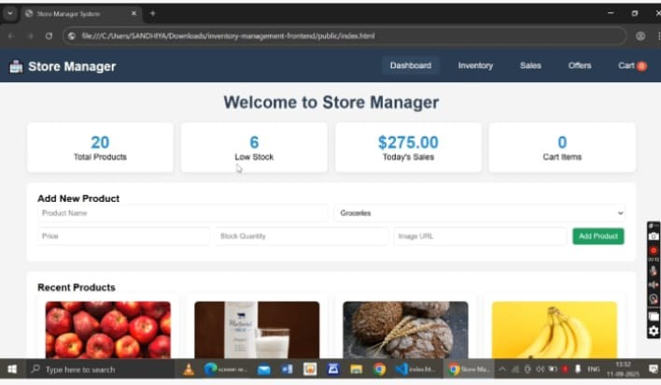

1. **Dashboard**

The dashboard gives an overview of the store. It displays total products, low stock items, today’s sales, and cart items. It also allows adding new products quickly and shows a list of recent products.

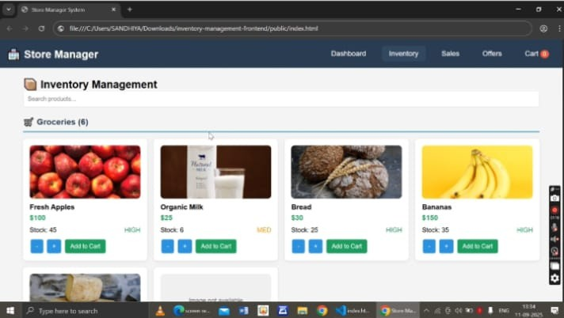

# Inventory Management

The inventory section lists available products with their price, stock quantity, and stock status (High/Medium/Low). Users can adjust quantities and add products directly to the cart.

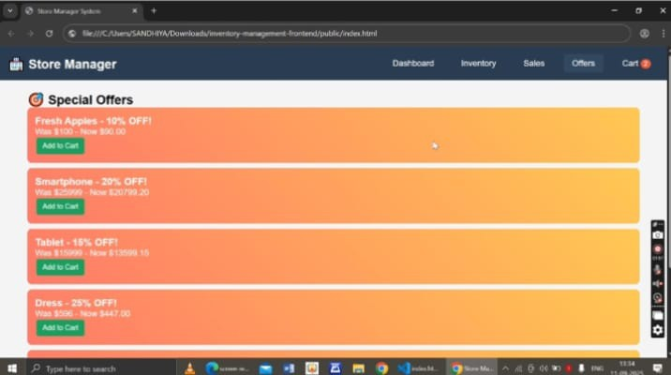

# Special Offers

This section highlights discounted products with the original and discounted prices. Users can directly add these offer items to their cart.

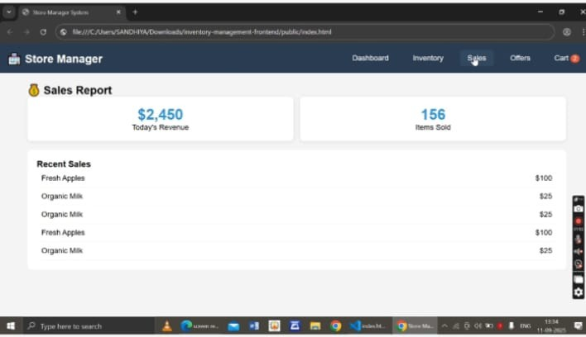

# Sales Report

The sales section shows today’s revenue and total items sold. It also lists recent sales transactions for easy tracking of store performance.

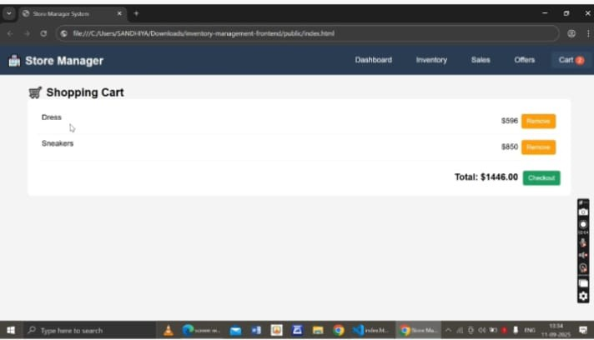

# Shopping Cart

The cart displays selected items with their prices, total amount, and options to remove items or proceed to checkout.

# Known Issues

(Placeholder: e.g., performance issues with large inventory, limited filtering options)

# Future Enhancements

* + Barcode scanning support.
  + Advanced analytics dashboard.
  + Multi-user support with authentication.
  + Export sales reports in CSV/PDF.